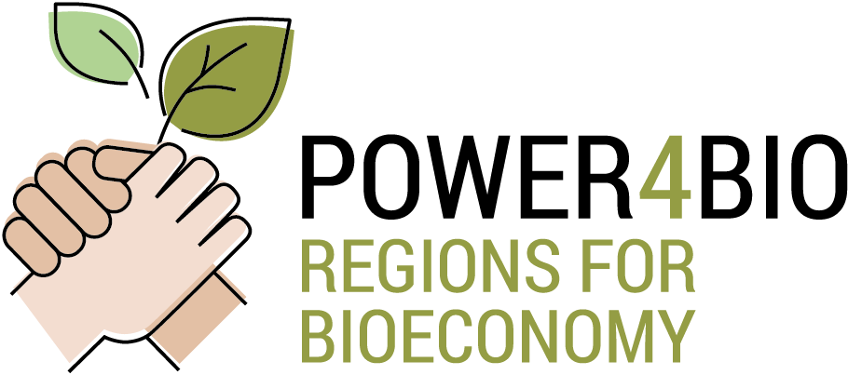

Agenda
Final Meeting General Assembly
Date: 12th March 2021
Online (WEBEX)
Item | Time | Subject | Speaker
10.00 |  | Welcome and introduction | CIRCE
1 | 10.05 | Project General Overview, next steps towards project end  - Covid19 impact in POWER4BIO  - Feedback from P.O and plan  - Final report  - Review meeting  - Timeline and actions by partner (calendar) | CIRCE
2 | 10.30 | Status of M30 deliverables (What is left to do, Expected submission date, other comments) – 15 minutes each  Each presenter will present key results, latest achievements and overall conclusions. Also considerations towards deliverables finalization and submission in month 30
 | 10.30 | Review of WP2 results  - M8 - Final version of BSAT online  - D2.5 - POWER4BIO BSAT | CIRCE
 | 10.45 | Review of WP5 results  - D5.3 - Summaries of 5 new regional bioeconomy strategies  - D5.4 - Summaries of 5 new regional implementation plans  - D5.5 - Summary report on specific interventions. | DBFZ
 | 11.00 | Review of WP6 results  - D6.1 - Summary report of the cross visits  - D6.3 - Report on actions to foster participation of regional stakeholders in international networks  - D6.4 - Training design and materials for increasing the bioeconomy capacity of regional stakeholders | AKI
 | 11.15 | Review of WP7 results  - D7.4 - POWER4BIO exploitation and sustainability plan  - D7.5 - Report on the activities of the Community of Interest (CoI)  - D7.6 - Final Report on dissemination & communication activities | EPC
3 | 11.30 | Impacts of the Project and interaction with Policy Makers at EU level | CIRCE
4 | 11.45 | Conclusions, General Assembly / Steering Committee discussion on any relevant issues | ALL
12.00 |  | End of meeting

Attendees:
Name | Entity
Ignacio Martín | 1. CIRCE - Fundación CIRCE | ES
Maider Gómez | 1. CIRCE - Fundación CIRCE | ES
Marcelino Gómez | 1. CIRCE - Fundación CIRCE | ES
Montserrat Lanero | 1. CIRCE - Fundación CIRCE | ES
Laura García | 2. DBFZ - Deutsches Biomasseforschungszentrum Gemeinnuetzige GMBH | DE
Nora Szarka | 2. DBFZ - Deutsches Biomasseforschungszentrum Gemeinnuetzige GMBH | DE
Bomin Yuan | 2. DBFZ - Deutsches Biomasseforschungszentrum Gemeinnuetzige GMBH | DE
Martien Van den Oever | 3. WR - STICHTING WAGENINGEN RESEARCH | NL
Berien Elbersen | 3. WR - STICHTING WAGENINGEN RESEARCH | NL
Francesca Natali | 4. META - META GROUP SRL | IT
Francesco Rocciola | 4. META - META GROUP SRL | IT
Norbert Potori | 5. AKI - AGRARGAZDASAGI KUTATO INTEZET | HU
Istvan Kulmany | 5. AKI - AGRARGAZDASAGI KUTATO INTEZET | HU
Christine Beusch | 6. EPC- EPC PROJEKTGESELLSCHAFT FÜR KLIMA | DE
Ulrich Eimer | 6. EPC- EPC PROJEKTGESELLSCHAFT FÜR KLIMA | DE
KATERINA VALTA | 7. DRAXIS - DRAXIS ENVIRONMENTAL S.A. | EL
Akos Koos | 8. BZN - BAY ZOLTAN ALKALMAZOTT KUTATASI KOZHASZNU NONPROFIT KFT | HU
Nora Hatvani | 8. BZN - BAY ZOLTAN ALKALMAZOTT KUTATASI KOZHASZNU NONPROFIT KFT | HU
Katalin Kalai | 8. BZN - BAY ZOLTAN ALKALMAZOTT KUTATASI KOZHASZNU NONPROFIT KFT | HU
Orest Kiyko | 9. UNFU - Ukrainian National Forestry University | UA
Sol Cuenca | 10. CAPDER - CONSEJERIA DE AGRICULTURA, PESCA Y DESARROLLO RURAL | ES
Natividad Pérez | 10. CAPDER - CONSEJERIA DE AGRICULTURA, PESCA Y DESARROLLO RURAL | ES
Marek Pszonka | 11. MAE - MAZOWIECKA AGENCJA ENERGETYCZNA SPZOO | PL
Bartosz Dubiński | 11. MAE - MAZOWIECKA AGENCJA ENERGETYCZNA SPZOO | PL
Eva Cudlínová | 12. USB - JIHOCESKA UNIVERZITA V CESKYCH BUDEJOVICICH | CZ
Miloslav Lapka | 12. USB - JIHOCESKA UNIVERZITA V CESKYCH BUDEJOVICICH | CZ
Laura Kuehn | 13. CCB - CHEMIE CLUSTER BAYERN GMBH | DE
Sara Cantone | 14. SPRING- Sustainable Processes and Res. for Innovation and National Growth | IT
Dries Maes | 15. EWI - VLAAMS GEWEST | BE
Monika Sormann | 15. EWI - VLAAMS GEWEST | BE
Danka Moravcikova | 16. SUA - SUA SLOVENSKA POLNOHOSPODARSKA UNIVERZITA V NITRE | SK
Martin Valach | 16. SUA - SUA SLOVENSKA POLNOHOSPODARSKA UNIVERZITA V NITRE | SK
Renatka Krcova | 17. ECRN - European Chemical Regions Network (ECRN) e.V. | DE

